Session 2 - 1

import java.util.HashMap;
import java.util.Map;

class UndergroundSystem {

private static class CheckInInfo {
String stationName;
int checkInTime;

CheckInInfo(String stationName, int checkInTime) {
this.stationName = stationName;
this.checkInTime = checkInTime;
}
}

private static class RouteStats {
double totalTime;
int tripCount;

RouteStats(double totalTime, int tripCount) {
this.totalTime = totalTime;
this.tripCount = tripCount;
}
}

private Map<Integer, CheckInInfo> activeCheckIns;
private Map<String, RouteStats> routeStatsMap;

public UndergroundSystem() {
activeCheckIns = new HashMap<>();
routeStatsMap = new HashMap<>();
}

public void checkIn(int id, String stationName, int t) {
activeCheckIns.put(id, new CheckInInfo(stationName, t));
}

public void checkOut(int id, String stationName, int t) {
CheckInInfo info = activeCheckIns.remove(id);
String routeKey = info.stationName + "->" + stationName;
int travelTime = t - info.checkInTime;

RouteStats stats = routeStatsMap.getOrDefault(routeKey, new RouteStats(0, 0));
stats.totalTime += travelTime;
stats.tripCount += 1;

routeStatsMap.put(routeKey, stats);
}

public double getAverageTime(String startStation, String endStation) {
String routeKey = startStation + "->" + endStation;
RouteStats stats = routeStatsMap.get(routeKey);
return stats.totalTime / stats.tripCount;
}
}
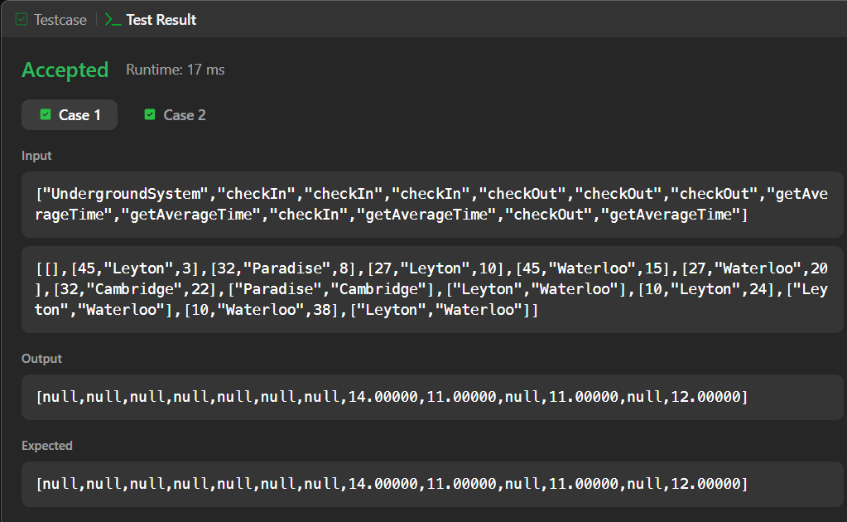

Session 2 -2

import java.util.ArrayList;
import java.util.List;

class BrowserHistory {
private List<String> history;
private int currentIndex;
private int maxIndex;

public BrowserHistory(String homepage) {
history = new ArrayList<>();
history.add(homepage);
currentIndex = 0;
maxIndex = 0;
}

public void visit(String url) {
currentIndex++;
if (currentIndex < history.size()) {
history.set(currentIndex, url);
} else {
history.add(url);
}
maxIndex = currentIndex;
}

public String back(int steps) {
currentIndex = Math.max(0, currentIndex - steps);
return history.get(currentIndex);
}

public String forward(int steps) {
currentIndex = Math.min(maxIndex, currentIndex + steps);
return history.get(currentIndex);
}
}

